RDBMS Assignment: (Part – 2)
Q. Create a database structure for e-commerce application.
User Table | Product
create table app_User  (  u_id int primary key,  u_name varchar2(20),  u_email varchar2(25) NOT NULL,  password varchar2(12) CHECK (LENGTH(password) >=8) NOT NULL)  );  SQL> Table created. | create table product  (  prod_id int primary key,  prod_name varchar2(20) NOT NULL,  price int NOT NULL,  u_id int  );  SQL> Table created.

Cust-order | Transaction
create table cust_order  (  o_id int PRIMARY KEY,  o_cost int, p_id int REFERENCES product(prod_id),  u_id int REFERENCES app_User(u_id) );  SQL> Table created. | create table cust_order  (  o_id int PRIMARY KEY,  o_cost int,  p_id int REFERENCES product(prod_id),  u_id int REFERENCES app_User(u_id)  );  SQL> Table created.

ALTER TABLE product ADD FOREIGN KEY (u_id) REFERENCES app_User(u_id) SQL> Table altered.

Add Data in all tables:
- app_Cust table:

- insert into app_user values(1, 'rohit45', 'rohitpatil@gmail.com', "Rohit045");
- insert into app_user values(2, 'Komal123', 'Komal@gmail.com', "Komal005");
- insert into app_user values(3, 'Vipul5', 'vipul@gmail.com', "Vipul123");
4) insert into app_user values(4, 'Achal01', 'Achal@gmail.com', "Achal25");
- insert into app_user values(5, 'pranjal', 'pranjal@gmail.com', "Pranjal1");
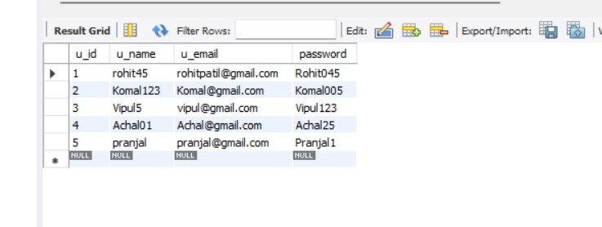

2) Product Table:
- insert into product values(1001, 'Speaker', 3500, 2);
2)insert into product values(1002, 'Shirt', 800, 4);
3)insert into product values(1003, 'Mobile', 80000, 3);
4)insert into product values(1004, 'TV', 16500, 1);
5)insert into product values(1005, 'Books', 500, 5);

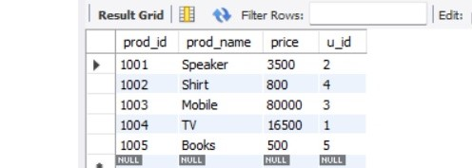

- cust_order Table:

1) insert into cust_order values(501, 3500, 1001, 2);
2) insert into cust_order values(502, 80000, 1003, 3);
3) insert into cust_order values(504, 16500, 1004, 1);
4) insert into cust_order values(503, 500, 1005, 5);
5) insert into cust_order values(505, 800, 1002, 4);

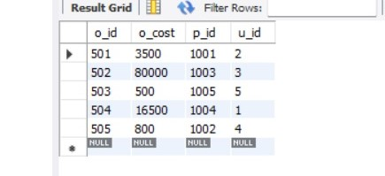

4)Transaction table:
nsert into transaction values(123, '27-NOV-2021', 10, 'COD', 'Not Paid', 501, 'Pune', user_id,5);
insert into transaction values(124, '27-NOV-2021', 15, 'Debit Card', 'Paid', 505, 'Nashik', 2);

insert into transaction values(125, '27-NOV-2021', 5, 'PhonePay', 'Paid', 503, 'Jalgaon',1);.

insert into transaction values(126, '27-NOV-2021', 15, 'GPAY', 'Paid', 502, 'Mumbai'. 3);

insert into transaction values(127, '27-NOV-2021', 15, 'CASH', 'Not Paid', 504, 'Pune',5);

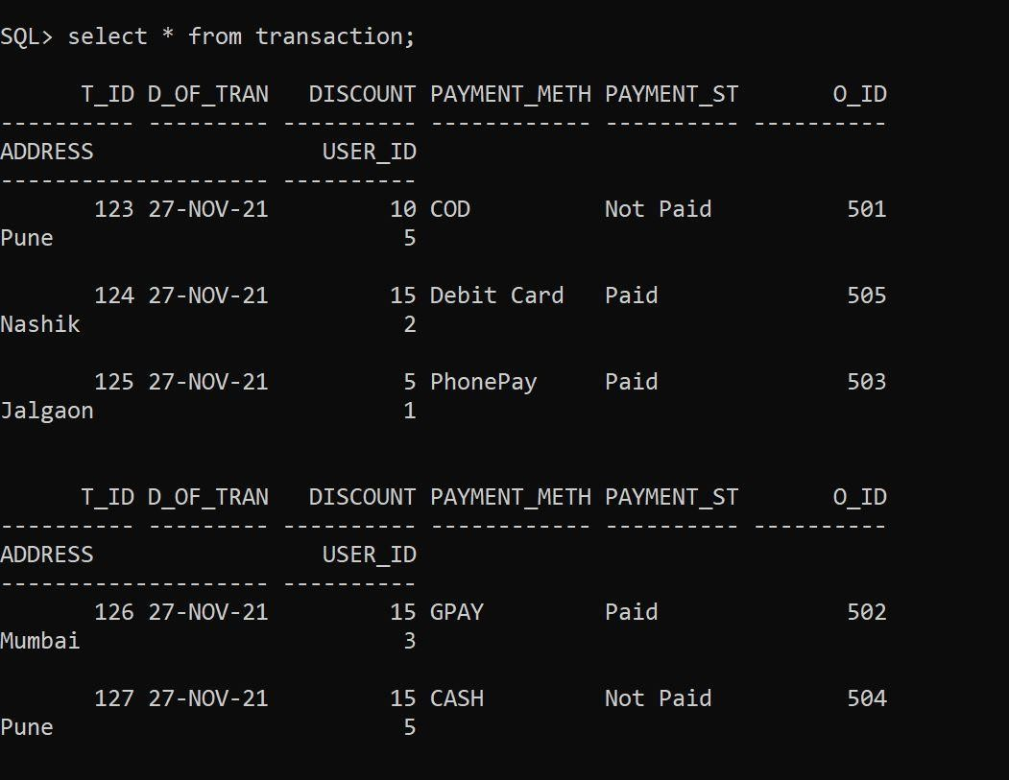

Q. 1. Create db view with order details of products sold.

Oídeí Id | Oídeí ľotal (total of those píoducts that belongs to useí) | Date | Discount | Payment method | Payment status

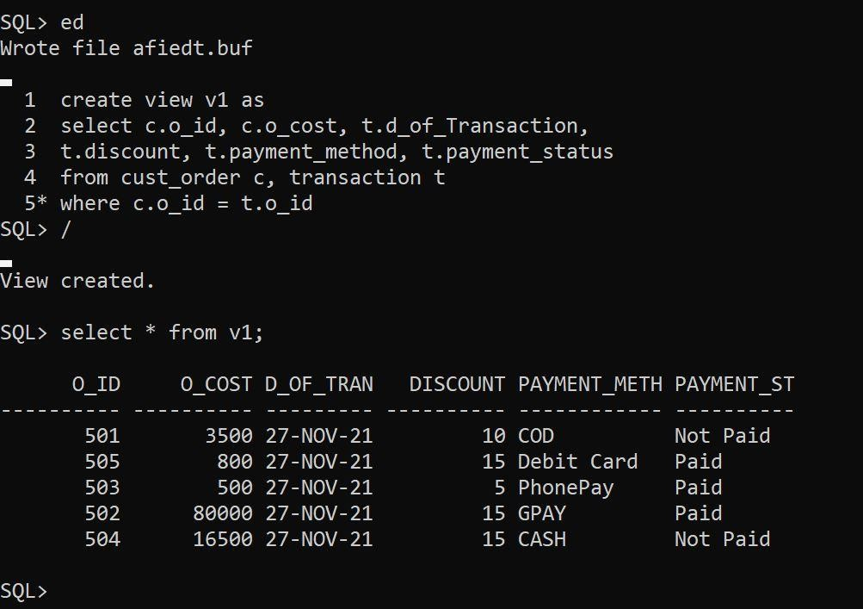
create view v1 as
select c.o_id, c.o_cost, t.d_of_Transaction,
t.discount, t.payment_method, t.payment_status
from cust_order c, transaction t where c.o_id = t.o_id;
oídeí_id | Oídeí Date | píoduct names | cost of each píoduct | total cost of oídeí(sum of all píoducts) | useí name | email

2. Geneíate a monthly íepoít with oídeís, píoducts and useís details foí finance dept. ľhe píimaíy key in this íepoít will be oídeí_id. ľhe íepoít should automatically take last 30 days.

oídeí_id | Oídeí Date | píoduct names | cost of each píoduct | total cost of oídeí(sum of all píoducts) | useí name | email

select O.o_id, O.o_cost, p.prod_name, p.price, u.u_name, u.u_email
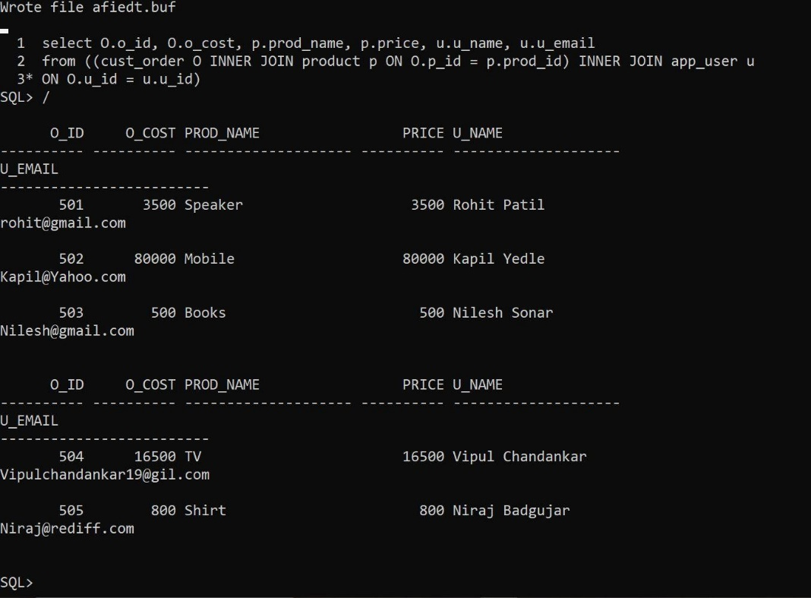
from ((cust_order O INNER JOIN product p ON O.p_id = p.prod_id) INNER JOIN app_user u ON O.u_id = u.u_id)

